Step Step
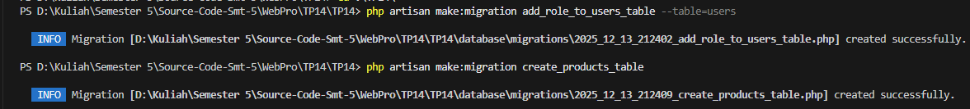
Hasil
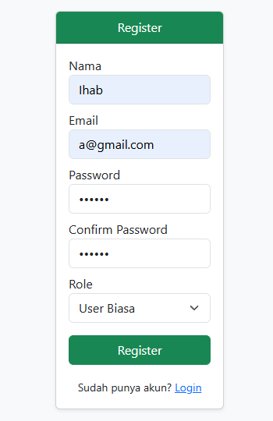
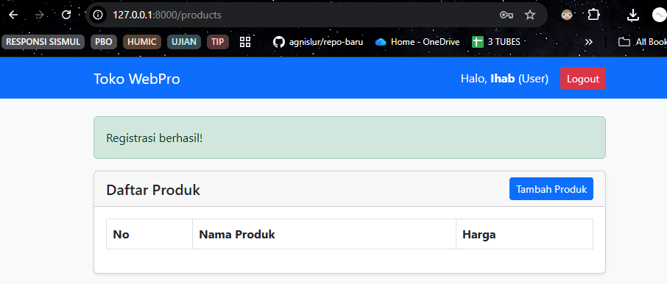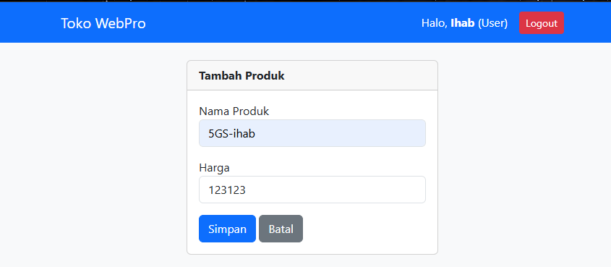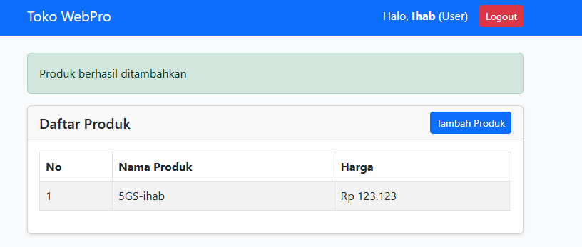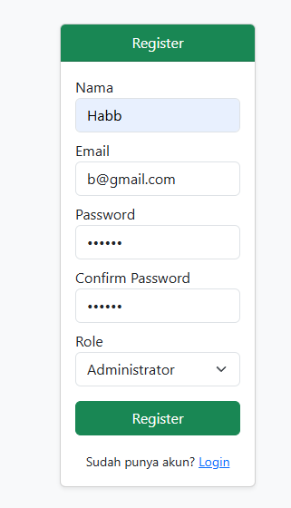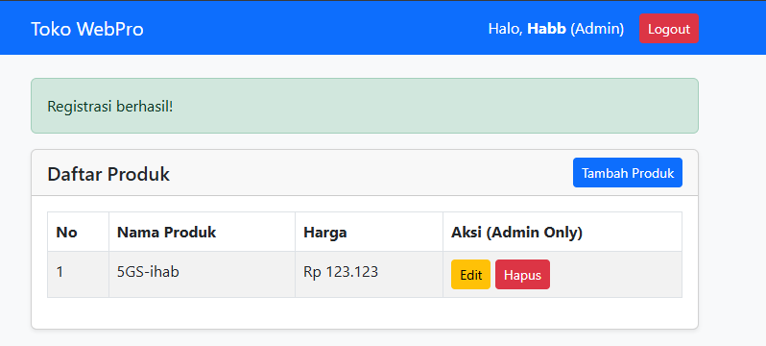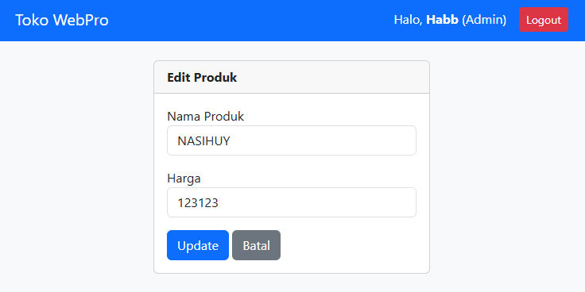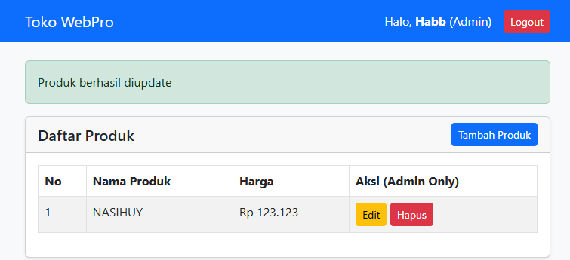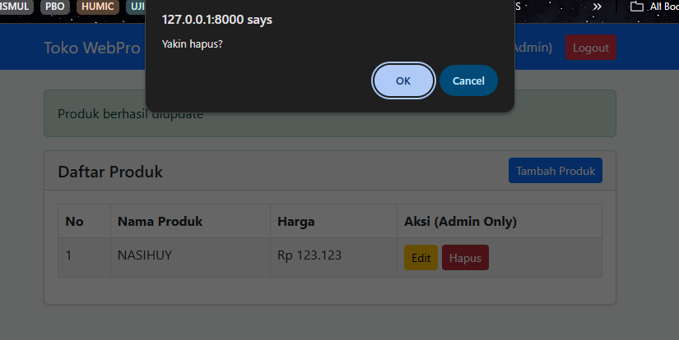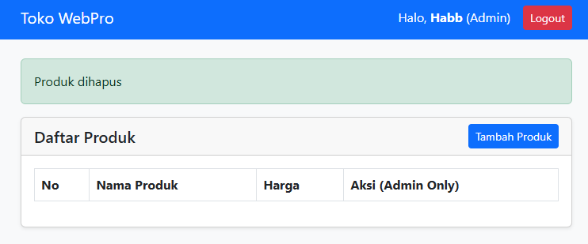
Kode
Routes
<?php

use Illuminate\Support\Facades\Route;
use App\Http\Controllers\AuthController;
use App\Http\Controllers\ProductController;

// Guest Routes
Route::middleware('guest')->group(function () {
Route::get('/', [AuthController::class, 'showLogin'])->name('login'); // Halaman awal login
Route::get('/login', [AuthController::class, 'showLogin']);
Route::post('/login', [AuthController::class, 'login']);
Route::get('/register', [AuthController::class, 'showRegister'])->name('register');
Route::post('/register', [AuthController::class, 'register']);
});

// Authenticated Routes
Route::middleware('auth')->group(function () {
Route::post('/logout', [AuthController::class, 'logout'])->name('logout');

// Product Routes
Route::resource('products', ProductController::class);
});

Model User
<?php

namespace App\Models;

// use Illuminate\Contracts\Auth\MustVerifyEmail;
use Illuminate\Database\Eloquent\Factories\HasFactory;
use Illuminate\Foundation\Auth\User as Authenticatable;
use Illuminate\Notifications\Notifiable;

class User extends Authenticatable
{
/** @use HasFactory<\Database\Factories\UserFactory> */
use HasFactory, Notifiable;

/**
* The attributes that are mass assignable.
*
* @var list<string>
*/
protected $fillable = [
'name',
'email',
'password',
'role', // Penting untuk mass assignment
];

/**
* The attributes that should be hidden for serialization.
*
* @var list<string>
*/
protected $hidden = [
'password',
'remember_token',
];

/**
* Get the attributes that should be cast.
*
* @return array<string, string>
*/
protected function casts(): array
{
return [
'email_verified_at' => 'datetime',
'password' => 'hashed',
];
}
}

Model Product
<?php

namespace App\Models;

use Illuminate\Database\Eloquent\Model;

class Product extends Model
{
protected $fillable = ['name', 'price'];
}

AuthController
<?php

namespace App\Http\Controllers;

use Illuminate\Http\Request;
use Illuminate\Support\Facades\Auth;
use Illuminate\Support\Facades\Hash;
use App\Models\User;

class AuthController extends Controller
{
public function showLogin() {
return view('auth.login');
}

public function login(Request $request) {
$credentials = $request->validate([
'email' => 'required|email',
'password' => 'required'
]);

if (Auth::attempt($credentials)) {
$request->session()->regenerate();
return redirect()->intended('/products');
}

return back()->with('error', 'Email atau password salah!');
}

public function showRegister() {
return view('auth.register');
}

public function register(Request $request) {
$validated = $request->validate([
'name' => 'required|string|max:255',
'email' => 'required|email|unique:users',
'password' => 'required|min:6|confirmed',
'role' => 'required|in:admin,user' // User memilih role saat register
]);

$user = User::create([
'name' => $validated['name'],
'email' => $validated['email'],
'password' => Hash::make($validated['password']),
'role' => $validated['role']
]);

Auth::login($user);
return redirect('/products')->with('success', 'Registrasi berhasil!');
}

public function logout(Request $request) {
Auth::logout();
$request->session()->invalidate();
$request->session()->regenerateToken();
return redirect('/login');
}
}
ProductController
<?php

namespace App\Http\Controllers;

use Illuminate\Http\Request;
use App\Models\Product;
use Illuminate\Support\Facades\Auth;

class ProductController extends Controller
{
public function index() {
$products = Product::all();
return view('products.index', compact('products'));
}

public function create() {
return view('products.create');
}

public function store(Request $request) {
$request->validate(['name' => 'required', 'price' => 'required|numeric']);
Product::create($request->all());
return redirect()->route('products.index')->with('success', 'Produk berhasil ditambahkan');
}

public function edit(Product $product) {
if (Auth::user()->role !== 'admin') {
return redirect()->route('products.index')->with('error', 'Akses ditolak!');
}
return view('products.edit', compact('product'));
}

public function update(Request $request, Product $product) {
if (Auth::user()->role !== 'admin') {
abort(403);
}
$request->validate(['name' => 'required', 'price' => 'required|numeric']);
$product->update($request->all());
return redirect()->route('products.index')->with('success', 'Produk berhasil diupdate');
}

public function destroy(Product $product) {
if (Auth::user()->role !== 'admin') {
abort(403);
}
$product->delete();
return redirect()->route('products.index')->with('success', 'Produk dihapus');
}
}
User Table
<?php

use Illuminate\Database\Migrations\Migration;
use Illuminate\Database\Schema\Blueprint;
use Illuminate\Support\Facades\Schema;

return new class extends Migration
{
/**
* Run the migrations.
*/
public function up()
{
Schema::table('users', function (Blueprint $table) {
// Default role adalah 'user'
$table->enum('role', ['admin', 'user'])->default('user')->after('email');
});
}

/**
* Reverse the migrations.
*/
public function down(): void
{
Schema::table('users', function (Blueprint $table) {
//
});
}
};

Product Table
<?php

use Illuminate\Database\Migrations\Migration;
use Illuminate\Database\Schema\Blueprint;
use Illuminate\Support\Facades\Schema;

return new class extends Migration
{
/**
* Run the migrations.
*/
public function up(): void
{
Schema::create('products', function (Blueprint $table) {
$table->id();
$table->string('name');
$table->integer('price');
$table->timestamps();
});
}

/**
* Reverse the migrations.
*/
public function down(): void
{
Schema::dropIfExists('products');
}
};

Layout
<!DOCTYPE html>
<html lang="en">
<head>
<meta charset="UTF-8">
<meta name="viewport" content="width=device-width, initial-scale=1.0">
<title>TP Modul 14</title>
<link href="https://cdn.jsdelivr.net/npm/bootstrap@5.3.0/dist/css/bootstrap.min.css" rel="stylesheet">
</head>
<body class="bg-light">

@auth
<nav class="navbar navbar-expand-lg navbar-dark bg-primary mb-4">
<div class="container">
<a class="navbar-brand" href="#">Toko WebPro</a>
<div class="d-flex text-white align-items-center gap-3">
<span>Halo, <strong>{{ Auth::user()->name }}</strong> ({{ ucfirst(Auth::user()->role) }})</span>
<form action="{{ route('logout') }}" method="POST">
@csrf
<button class="btn btn-sm btn-danger" type="submit">Logout</button>
</form>
</div>
</div>
</nav>
@endauth

<div class="container mt-4">
@if(session('success'))
<div class="alert alert-success">{{ session('success') }}</div>
@endif
@if(session('error'))
<div class="alert alert-danger">{{ session('error') }}</div>
@endif

@yield('content')
</div>

</body>
</html>
Login
@extends('layout')

@section('content')
<div class="row justify-content-center mt-5">
<div class="col-md-4">
<div class="card shadow-sm">
<div class="card-header bg-primary text-white text-center">Login</div>
<div class="card-body">
<form action="{{ url('/login') }}" method="POST">
@csrf
<div class="mb-3">
<label>Email</label>
<input type="email" name="email" class="form-control" required>
</div>
<div class="mb-3">
<label>Password</label>
<input type="password" name="password" class="form-control" required>
</div>
<button class="btn btn-primary w-100">Login</button>
</form>
<div class="text-center mt-3">
<small>Belum punya akun? <a href="{{ route('register') }}">Register</a></small>
</div>
</div>
</div>
</div>
</div>
@endsection
Register
@extends('layout')

@section('content')
<div class="row justify-content-center mt-5">
<div class="col-md-4">
<div class="card shadow-sm">
<div class="card-header bg-success text-white text-center">Register</div>
<div class="card-body">
<form action="{{ url('/register') }}" method="POST">
@csrf
<div class="mb-2">
<label>Nama</label>
<input type="text" name="name" class="form-control" required>
</div>
<div class="mb-2">
<label>Email</label>
<input type="email" name="email" class="form-control" required>
</div>
<div class="mb-2">
<label>Password</label>
<input type="password" name="password" class="form-control" required>
</div>
<div class="mb-2">
<label>Confirm Password</label>
<input type="password" name="password_confirmation" class="form-control" required>
</div>
<div class="mb-3">
<label>Role</label>
<select name="role" class="form-select">
<option value="user">User Biasa</option>
<option value="admin">Administrator</option>
</select>
</div>
<button class="btn btn-success w-100">Register</button>
</form>
<div class="text-center mt-3">
<small>Sudah punya akun? <a href="{{ route('login') }}">Login</a></small>
</div>
</div>
</div>
</div>
</div>
@endsection
Create
@extends('layout')

@section('content')
<div class="card col-md-6 mx-auto">
<div class="card-header fw-bold">Tambah Produk</div>
<div class="card-body">
<form action="{{ route('products.store') }}" method="POST">
@csrf
<div class="mb-3">
<label>Nama Produk</label>
<input type="text" name="name" class="form-control" required>
</div>
<div class="mb-3">
<label>Harga</label>
<input type="number" name="price" class="form-control" required>
</div>
<button class="btn btn-primary">Simpan</button>
<a href="{{ route('products.index') }}" class="btn btn-secondary">Batal</a>
</form>
</div>
</div>
@endsection
Edit
@extends('layout')

@section('content')
<div class="card col-md-6 mx-auto">
<div class="card-header fw-bold">Edit Produk</div>
<div class="card-body">
<form action="{{ route('products.update', $product->id) }}" method="POST">
@csrf
@method('PUT') <div class="mb-3">
<label>Nama Produk</label>
<input type="text" name="name" class="form-control" value="{{ old('name', $product->name) }}" required>
</div>

<div class="mb-3">
<label>Harga</label>
<input type="number" name="price" class="form-control" value="{{ old('price', $product->price) }}" required>
</div>

<button class="btn btn-primary">Update</button>
<a href="{{ route('products.index') }}" class="btn btn-secondary">Batal</a>
</form>
</div>
</div>
@endsection
Index
@extends('layout')

@section('content')
<div class="card shadow-sm">
<div class="card-header d-flex justify-content-between align-items-center">
<h5 class="mb-0">Daftar Produk</h5>
<a href="{{ route('products.create') }}" class="btn btn-sm btn-primary">Tambah Produk</a>
</div>
<div class="card-body">
<table class="table table-bordered table-striped">
<thead>
<tr>
<th>No</th>
<th>Nama Produk</th>
<th>Harga</th>
@if(Auth::user()->role == 'admin')
<th>Aksi (Admin Only)</th>
@endif
</tr>
</thead>
<tbody>
@foreach($products as $key => $p)
<tr>
<td>{{ $key + 1 }}</td>
<td>{{ $p->name }}</td>
<td>Rp {{ number_format($p->price, 0, ',', '.') }}</td>

@if(Auth::user()->role == 'admin')
<td>
<a href="{{ route('products.edit', $p->id) }}" class="btn btn-sm btn-warning">Edit</a>
<form action="{{ route('products.destroy', $p->id) }}" method="POST" class="d-inline" onsubmit="return confirm('Yakin hapus?')">
@csrf
@method('DELETE')
<button class="btn btn-sm btn-danger">Hapus</button>
</form>
</td>
@endif
</tr>
@endforeach
</tbody>
</table>
</div>
</div>
@endsection

